**Request the Reset of Password Scenario**

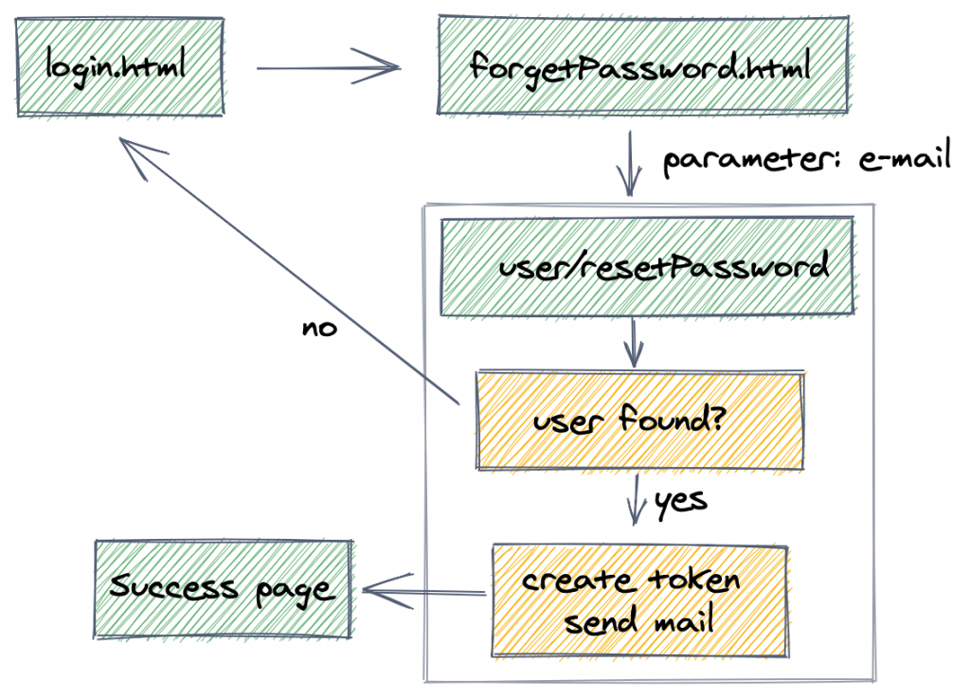

**Check Token and Reset Password Scenario**

